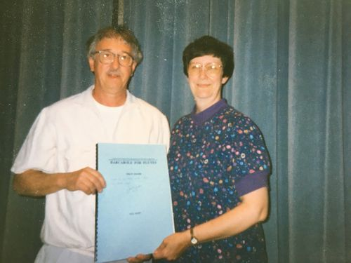

John P. Zdechlik
1937-2020

Passed away on May 21, 2020, at home in White Bear Lake, MN. Cherished husband of 58 years to Catherine (Baxter) Zdechlik; dedicated father of John (Marjorie), Mark (Amy) and Sarah Kolo (David); and delighted grandfather of Alina, Marya, Lily, Jack, Claire and Catherine. Also known and loved by Elisabeth and Nolan. Friend, mentor, and educator of many, he is remembered for his contribution to playing, teaching and composing music that made an impact around the world. Born in Minneapolis, he was writing music and playing for dance bands as a teenager. He attended the University of Minnesota for undergraduate and graduate degrees and was assistant director of bands there from 1963–1970; taught in St. Cloud, Taylor's Falls and Jordan; and joined the faculty at Lakewood Community College (now Century College) in 1970. He wrote more than sixty works for band and small ensembles, including Chorale and Shaker Dance, a standard in the repertoire. He loved the outdoors, life at the lake, camping, fishing, planning trips and traveling, gardening and golfing. He was impeccably organized and would find efficient, if unconventional, solutions. Inspired by global cuisine, he was an inventive cook who loved to entertain. His jokes were legendary groaners—every time he told them—and he always won at poker. Memorial plans will be announced at a later date.

