Dr. John Zdechlik
Through the Years

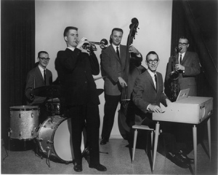 | 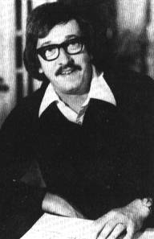 | 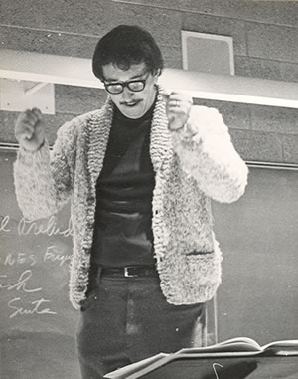
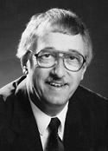 |  | 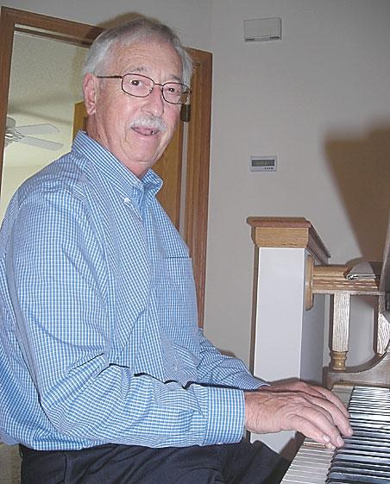

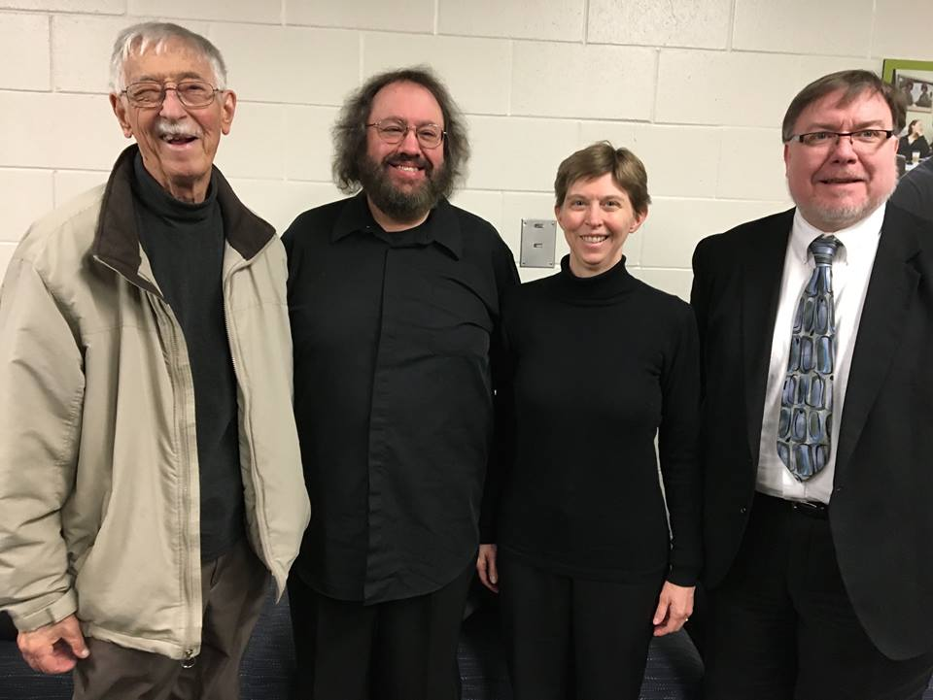
“Doc Z,” Charles Preis, Dr. Shirley Mier, Steven A. Kennedy

Conversation with daughter Sarah: https://www.youtube.com/watch?v=lZXRqmT7Z9E

White Bear Press > News

Musicians all over the world
can play a 'Concert in Z'
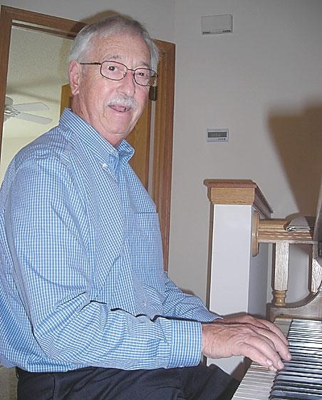
Music written by longtime White Bear resident and former Century College Music Director John Zdechlik will be highlighted during the “Concert in Z,” staged Oct. 17 at Mahtomedi High School. - Photo by Mark Nicklawske

White Bear Lake music teacher, composer honored with performance

by Mark Nicklawske
Regional Editor
Published:
Tuesday, October 12, 2010 6:30 PM CDT
WHITE BEAR LAKE — If you were a Minnesota high school band student at some point in the last five decades, there’s a pretty good chance you learned to play a piece written by John Zdechlik.
In fact, high school and college band students all across the country, in Europe and many in Asia have learned his arrangements too.
Brass band, marching band, jazz band, you name it, Zdechlik has composed, taught and played a tune for everyone.
This Sunday, the Wild Prairie Brass Choir and the Mahtomedi High School Symphonic Band will celebrate the music of Zdechlik, a White Bear resident and Century College Music Department founder, with a free performance. “The Concert in Z” will take place at 2 p.m. Sunday, Oct. 17 at the Chautauqua Fine Arts Center in Mahtomedi.
“John is known just about everywhere in the instrumental and choral music world,” said Mary Brindle, co-founder of the west metro-based Wild Prairie Brass Choir. “We wanted to honor him and the contributions he’s made to the music for so many years. He’s written so much wonderful music, we’re going to play it up in a real big way.”
“The Concert in Z” will wrap up at around two hours, but if musicians were to play all the music Zdechlik has made the show would take weeks.
Zdechlik, 73, discussed his music career in the sun room of the town home he shares with his wife Katie. The windows look out over a large marsh just north of White Bear Lake. Artwork hangs on walls and is displayed in bookcases all over the house. A blonde-wood grand piano is the living room centerpiece.
As a teenager, Zdechlik (pronounced “Zee-deck-lick”) would compose original music and write big band arrangements for 1950s pop tunes sung by people like Frank Sinatra. His parents discovered he had a gift for music and moved a piano into an upstairs room of their north Minneapolis home.
“I created a music studio for myself. It was a place where I could shut the door and be by myself and write music,” he said.
Local singers would stop by with an original song and Zdechlik would notate the tune for $25. A teacher told him he needed to up his fees.
“He said, ‘They don’t think you know what you’re doing because you’re not charging enough,’” said Zdechlik.
But Zdechlik did know what he was doing. At 17, he joined a dance band called the Denny Murphy Band and played trumpet in shows all over Minneapolis. The group played Count Basie, Benny Goodman and Les Brown, the hit music of the day.
Zdechlik took lessons from anyone who would give him the time.
“I remember going down to the strip joints on Hennepin Avenue to take a lesson,” he said. “I’d go down there during off hours and there was a guy that would teach me some jazz stuff. I reached out to people that I respected, good musicians, and they helped me out a little.”
Still Zdechlik’s father, who worked for the telephone company, thought his son needed to find a more respectable career: “He said to me once, ‘Are you going to be playing in bars all your life?’ He was worried I’d just be playing in joints all the time.”
But Zdechlik took his musical talent to the University of Minnesota where he earned a teaching degree. He taught music at Taylors Falls High School for a couple of years — where he met Katie, another teacher — and later returned to the U of M in 1962 for graduate work.
These were the glory days of the University of Minnesota football team — and Zdechlik wrote an arrangement based on a George Gershwin tune for the marching band.
“(The band had) a new director and I wanted to get to know him, so I wrote this piece and submitted it,” he said. “They wound up playing it at the Rose Bowl.”
Zdechlik joined the U of M staff as an assistant band director where he worked closely with high schools all over the state and continued his composition work.
In 1970, he received his doctorate in composition and music theory and was hired to start the music department at what was then called Lakewood Community College in White Bear Lake. “It gave me the opportunity to create what I wanted,” he said. “It was kind of an outpost in those days, but over the years it’s grown a lot.”
Mahtomedi Band Director David Stevens said Zdechlik spent almost 30 years building the Century College music program working closely with high schools and the University of Minnesota. Enrollment grew rapidly, a music wing and theater were added to campus, a jazz festival was established in 1990 and a jazz band was created for former students.
All this time Zdechlik was also writing music — and publishing it.
A 1971 composition, “Chorale and Shaker Dance,” was a hit with band directors all over the world. With three children, the proceeds from the piece came in handy, building a new addition on his White Bear Lake home.
“It kind of opened the door for me,” he said. “I was very fortunate with that one.”
Zdechlik is still writing and arranging tunes and has had more than 40 works published for bands of all kinds. Over the years, he has toured the country, teaching and directing his compositions to young musicians everywhere — even after his 1997 retirement.
“He’s very prolific,” said Stevens. “It’s in his blood. He has these ideas and he enjoys getting them out.”
Stevens said Zdechlik crafts tuneful music that challenges musicians and satisfies an audience.
“His music is appreciated by both musicians and non-musicians,” he said. “John’s music really connects with an audience at an emotional level.”
Zdechlik said high school and college band programs have changed, like everything else, over the years. Young people have more choices now, which leads to a smaller pool of students.
But technology has improved teaching and learning. Computers project entire compositions on the wall for students to play.
“I never had anything like that,” he said. “I had to use an overhead ... or write it all out on the board.”
And still, everyone learned how to play a Zdechlik tune.
Mark Nicklawske can be reached at news@presspubs.com or 651-407-1231.

Copyright © 2010 - Press Publications

